AWS EC2 Pricing & Capacity Options
When you use AWS EC2, you are basically renting computers in the cloud.
AWS gives you different ways to:
- Pay less
- Reserve capacity
- Make sure servers are available when you need them
This explains the most important EC2 options in plain English, with examples anyone can understand.

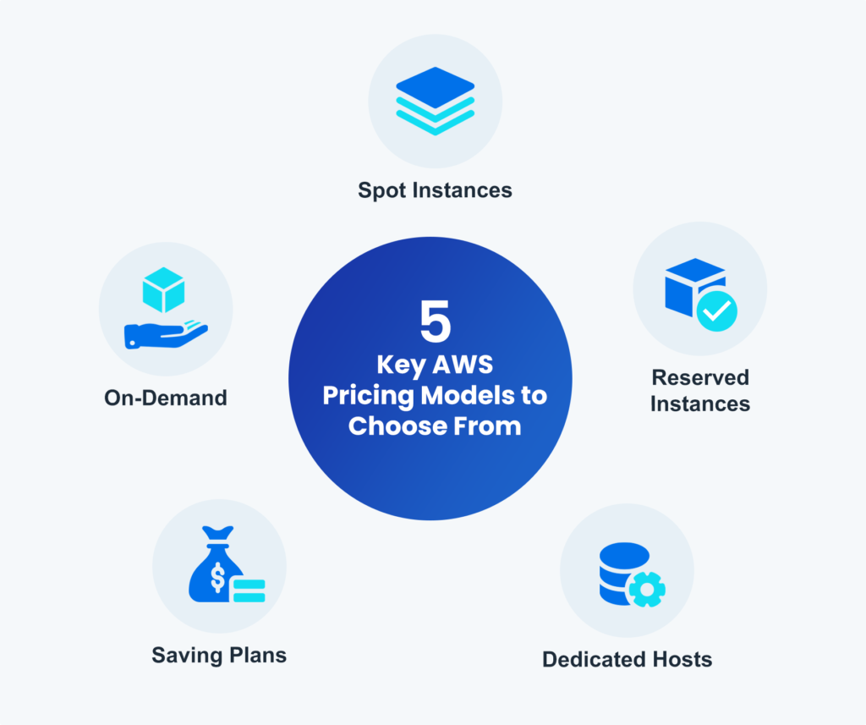

1. Spot Requests (Spot Instances)
What is it?
Spot Instances are extra unused servers that AWS sells at a very cheap price.
You don’t “own” them. You’re borrowing them when AWS has spare capacity.

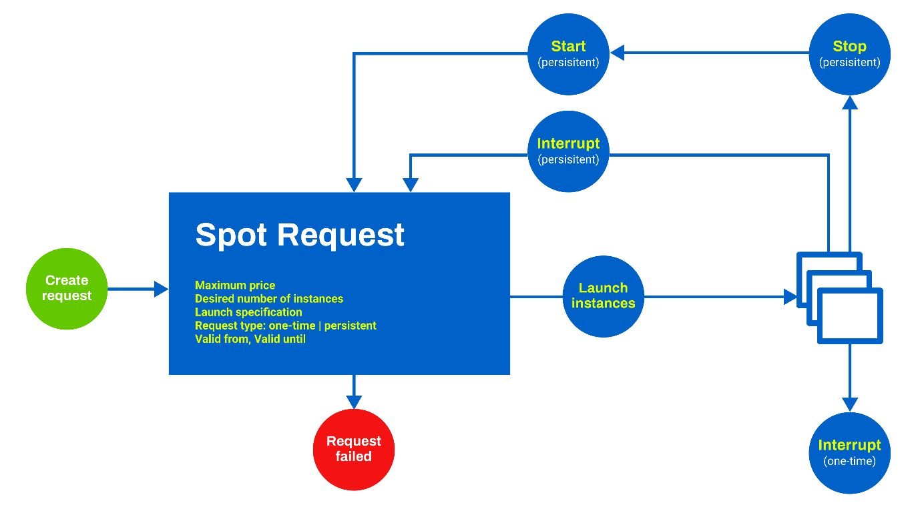

Why are they cheap?
Because AWS can take them back at any time if it needs them.
Real-life example
Think of airline standby tickets:
- Very cheap
- You only fly if there’s an empty seat
- You might be asked to leave if a paying customer shows up
Good for:
- Batch jobs
- Data processing
- Testing
- Background tasks

Not good for:
- Websites
- Databases
- Anything that must always be running
Key things to remember:
- Very cheap (up to 90% discount)
- Can stop anytime with a short warning
- Best when your work can restart easily

2. Savings Plans
What is it?
Savings Plans are a discount plan where you promise to spend a certain amount per hour on AWS.
In return, AWS gives you lower prices automatically.

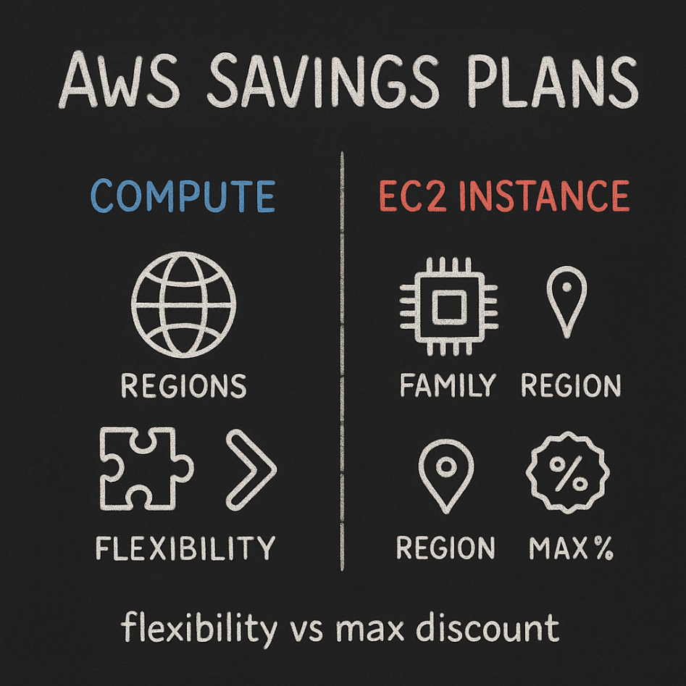

Important detail
You are not locking a specific server.
You are locking spending, not machines.
Real-life example
It’s like buying a monthly phone plan:
- You commit to paying every month
- Calls are cheaper than pay-as-you-go
- You can still change phones
Types (simple version):
- Compute Savings Plans – Most flexible
- EC2 Savings Plans – Bigger discount, less flexible
Good for:
- Long-term workloads
- Growing applications
- Teams that don’t want to manage pricing daily
Key things to remember:
- 1 or 3 year commitment
- Discounts apply automatically
- Easier than Reserved Instances

3. Reserved Instances (RIs)
What is it?
Reserved Instances mean you reserve a specific server type for 1 or 3 years.
AWS rewards this commitment with a big discount.
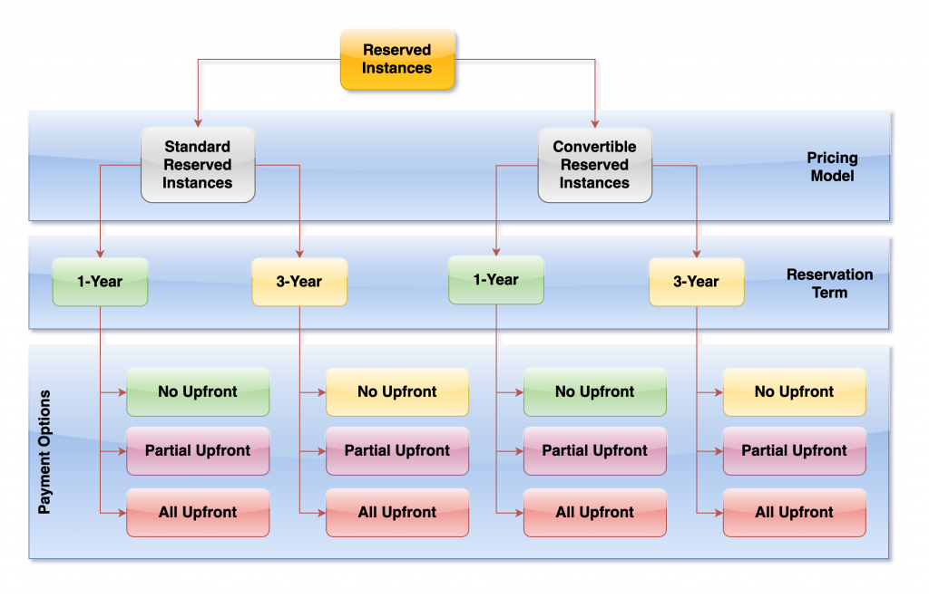
Real-life example
Like leasing an apartment:
- Cheaper than nightly hotel stays
- You’re locked into the location and size
Types:
- Standard RIs – Biggest discount, least flexible
- Convertible RIs – Smaller discount, more flexibility
Good for:
- Always-on applications
- Databases
- Backend services
Not good for:
- Short-term or changing workloads
Key things to remember:
- Cheaper than On-Demand
- Less flexible than Savings Plans
- Best when usage is very stable

4. Dedicated Hosts
What is it?
Dedicated Hosts give you a physical server just for you.
You control how instances are placed on that server.

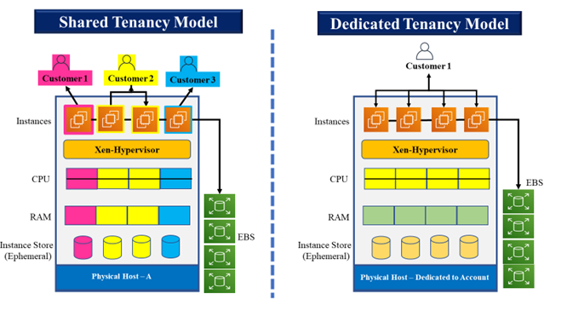

Why would anyone need this?
Mainly for:
- Legal requirements
- Software licenses tied to physical machines
- Compliance rules
Real-life example
Renting an entire building instead of a single apartment.
Good for:
- Big enterprises
- Special licensing needs

Key things to remember:
- Expensive
- Rarely needed
- Maximum control and isolation

5. Capacity Reservations
What is it?
Capacity Reservations guarantee that EC2 capacity is available when you need it.
You pay to hold the space, even if you’re not using it yet.
Important clarification
This is about availability, not discounts.

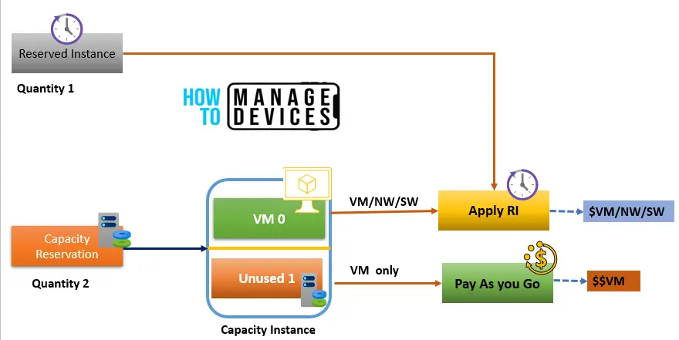

Real-life example
Booking seats in a movie theater:
- You pay to reserve seats
- Seats are guaranteed
- Whether you show up or not, the seats are held
Good for:
- Critical workloads
- Planned launches
- Disaster recovery setups
Key things to remember:
- Guarantees capacity in a specific region/AZ
- You pay even if instances aren’t running
- Often combined with Savings Plans or RIs

6. Capacity Manager
What is it?
Capacity Manager helps you automatically manage and monitor EC2 capacity.
It makes sure your applications always have servers available without manual work.
Real-life example
A hotel manager who:
- Tracks room availability
- Prepares rooms before guests arrive
- Makes sure no one is left without a room
Good for:
- Large systems
- Auto-scaling environments
- Teams that want fewer outages
Key things to remember:
- Reduces manual capacity planning
- Works well with reservations and scaling
- Improves reliability

Simple Comparison Table
Feature | Main Purpose
Spot Requests | Cheapest servers (not guaranteed)
Savings Plans | Long-term discounts (flexible)
Reserved Instances | Long-term discounts (fixed)
Dedicated Hosts | Physical server just for you
Capacity Reservations | Guaranteed availability
Capacity Manager | Automates capacity planning

Final Thoughts
AWS gives you many options because different workloads have different needs.
A smart setup usually combines:
- Savings Plans for steady usage
- Spot Instances to save money
- Capacity Reservations for critical systems
Once you understand why each option exists, choosing the right one becomes much easier.

